2200030216 TASK4-WEEK1

EXERCISE 7 :-- **Financial Forecasting**

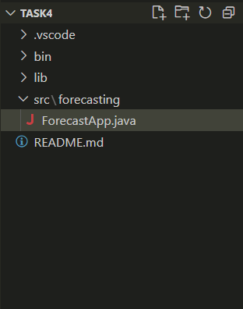

Output:

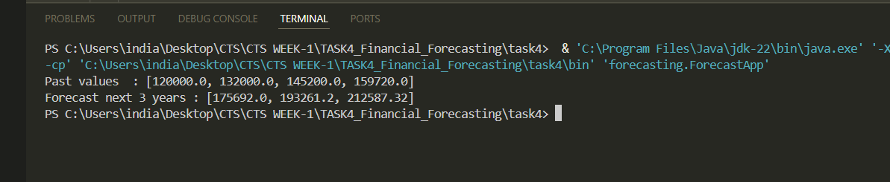

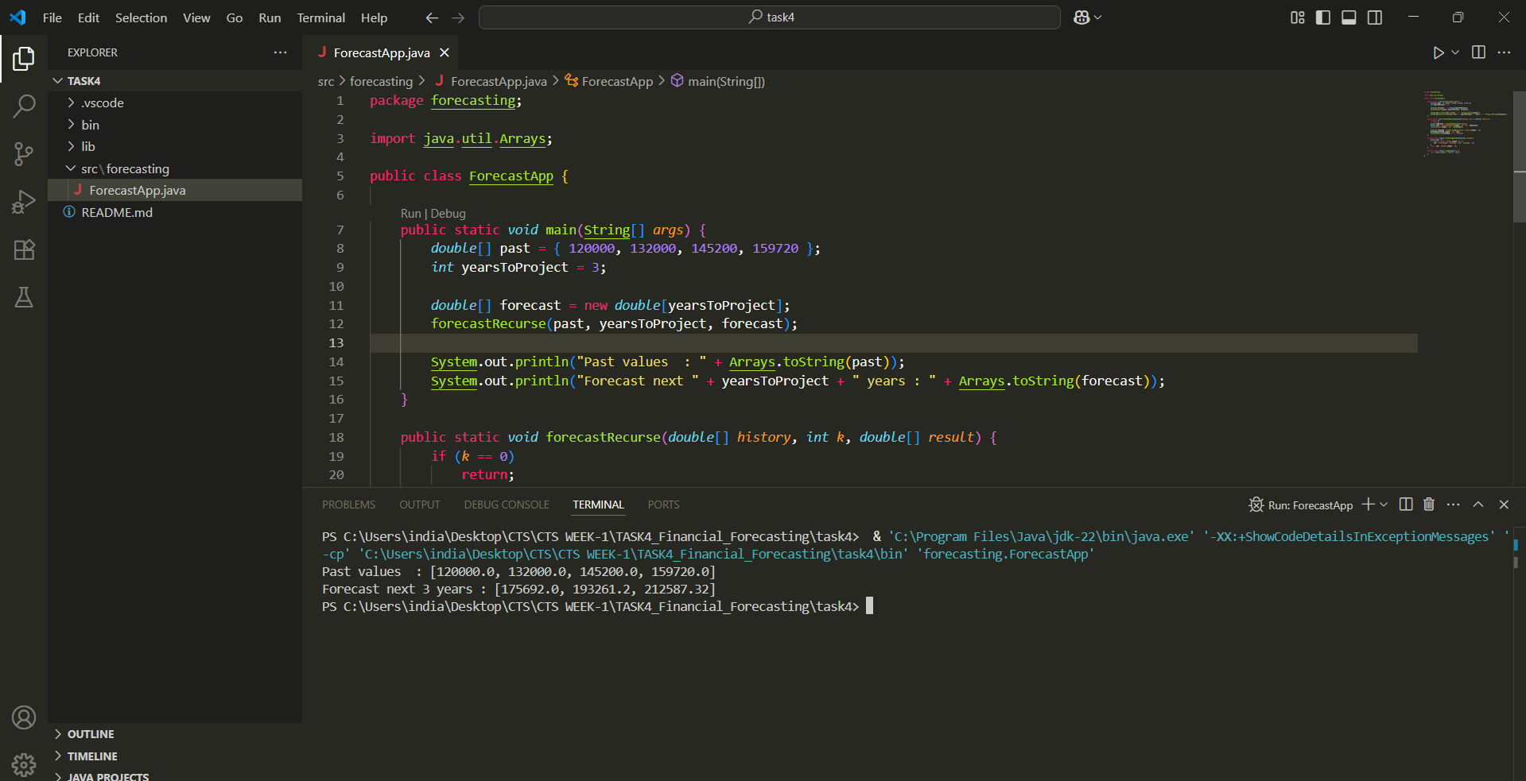

ForecastApp.java

package forecasting;

import java.util.Arrays;

public class ForecastApp {

    public static *void* main(String[] *args*) {

*double*[] past = {120000, 132000, 145200, 159720};

*int* yearsToProject = 3;

*double*[] forecast = new *double*[yearsToProject];

        forecastRecurse(past, yearsToProject, forecast);

        System.out.println("Past values  : " + Arrays.toString(past));

        System.out.println("Forecast next " + yearsToProject + " years : " + Arrays.toString(forecast));

    }

    public static *void* forecastRecurse(*double*[] *history*, *int* *k*, *double*[] *result*) {

        if (*k* == 0) return;

*double* avgGrowth = calcAverageGrowth(*history*);

*double* next = *history*[*history*.length - 1] * (1 + avgGrowth);

*result*[*result*.length - *k*] = round2(next);

*double*[] extended = Arrays.copyOf(*history*, *history*.length + 1);

        extended[extended.length - 1] = next;

        forecastRecurse(extended, *k* - 1, *result*);

    }

    private static *double* calcAverageGrowth(*double*[] *values*) {

*double* sum = 0;

        for (*int* i = 1; i < *values*.length; i++) {

            sum += (*values*[i] - *values*[i - 1]) / *values*[i - 1];

        }

        return sum / (*values*.length - 1);

    }

    private static *double* round2(*double* *v*) {

        return Math.round(*v* * 100.0) / 100.0;

    }

}